COST OPTIMISATION EC2 EBS SNAPSHOT

1. Launch a ec2- instance

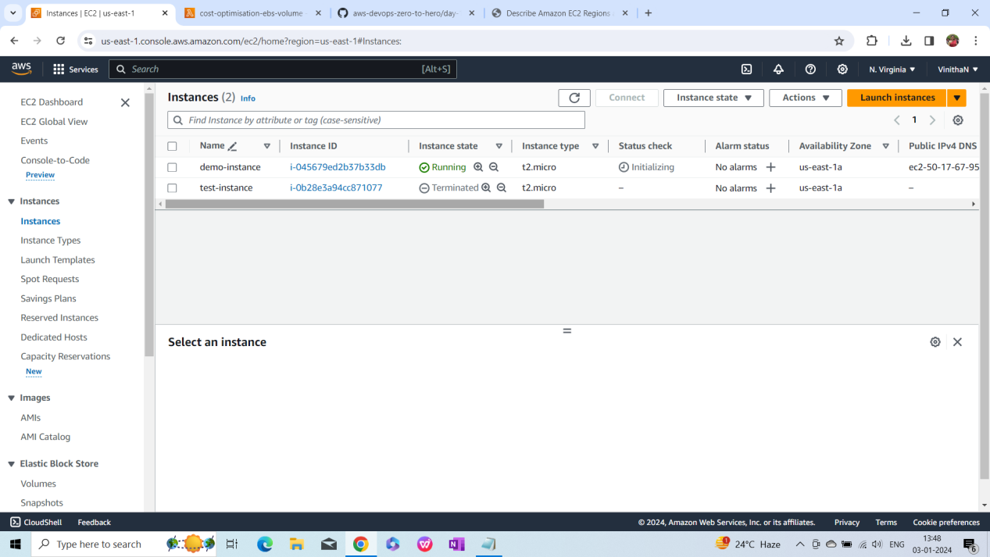

1. Volume also gets created with ec2-instance

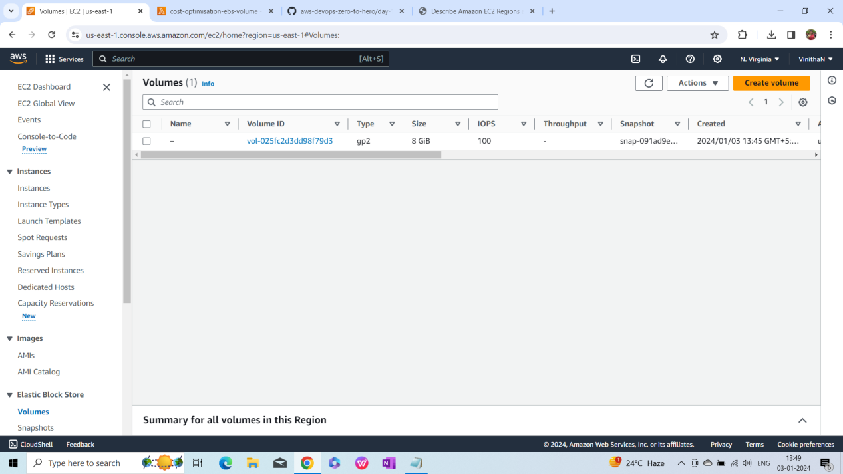

1. Create a snapshot for that volume id

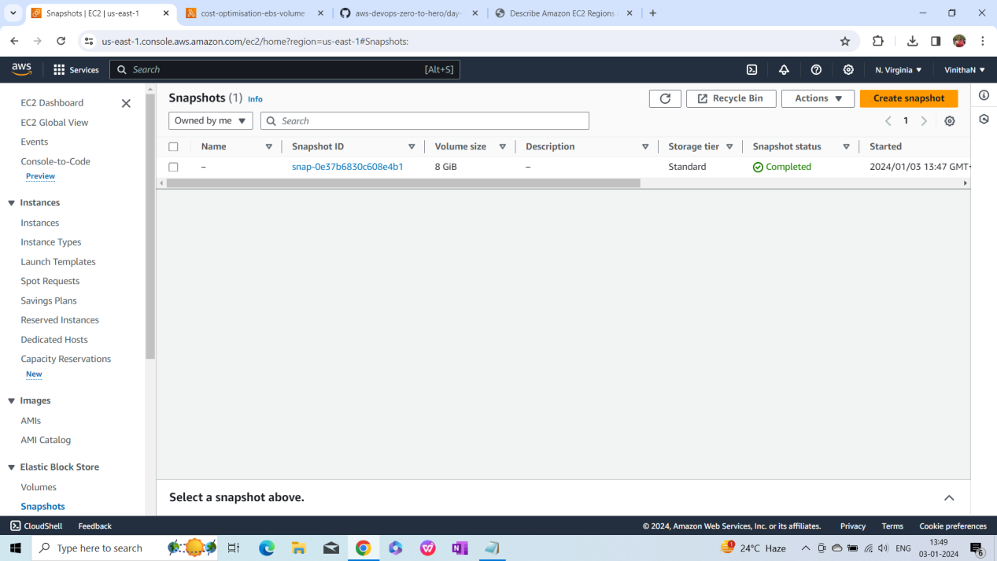

1. Create a Lambda function

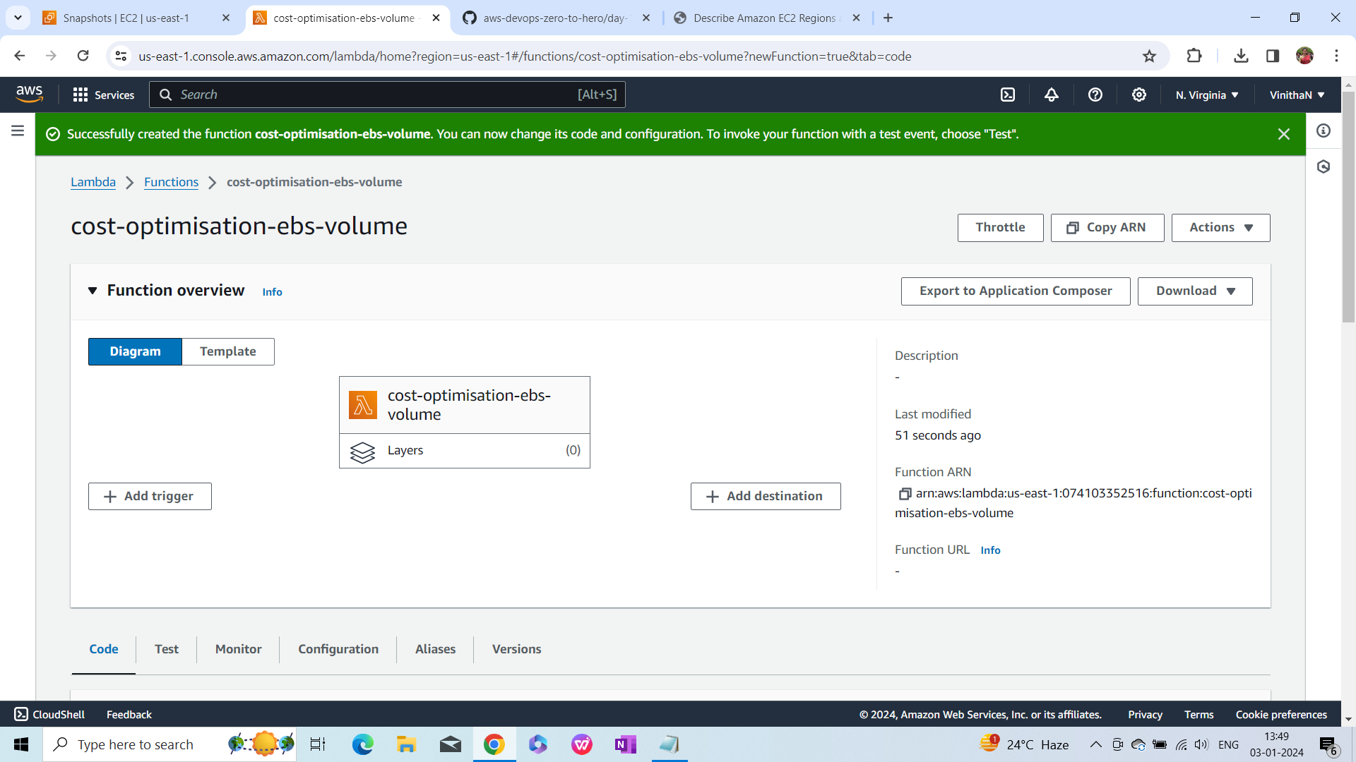

1. Paste the code in Code section

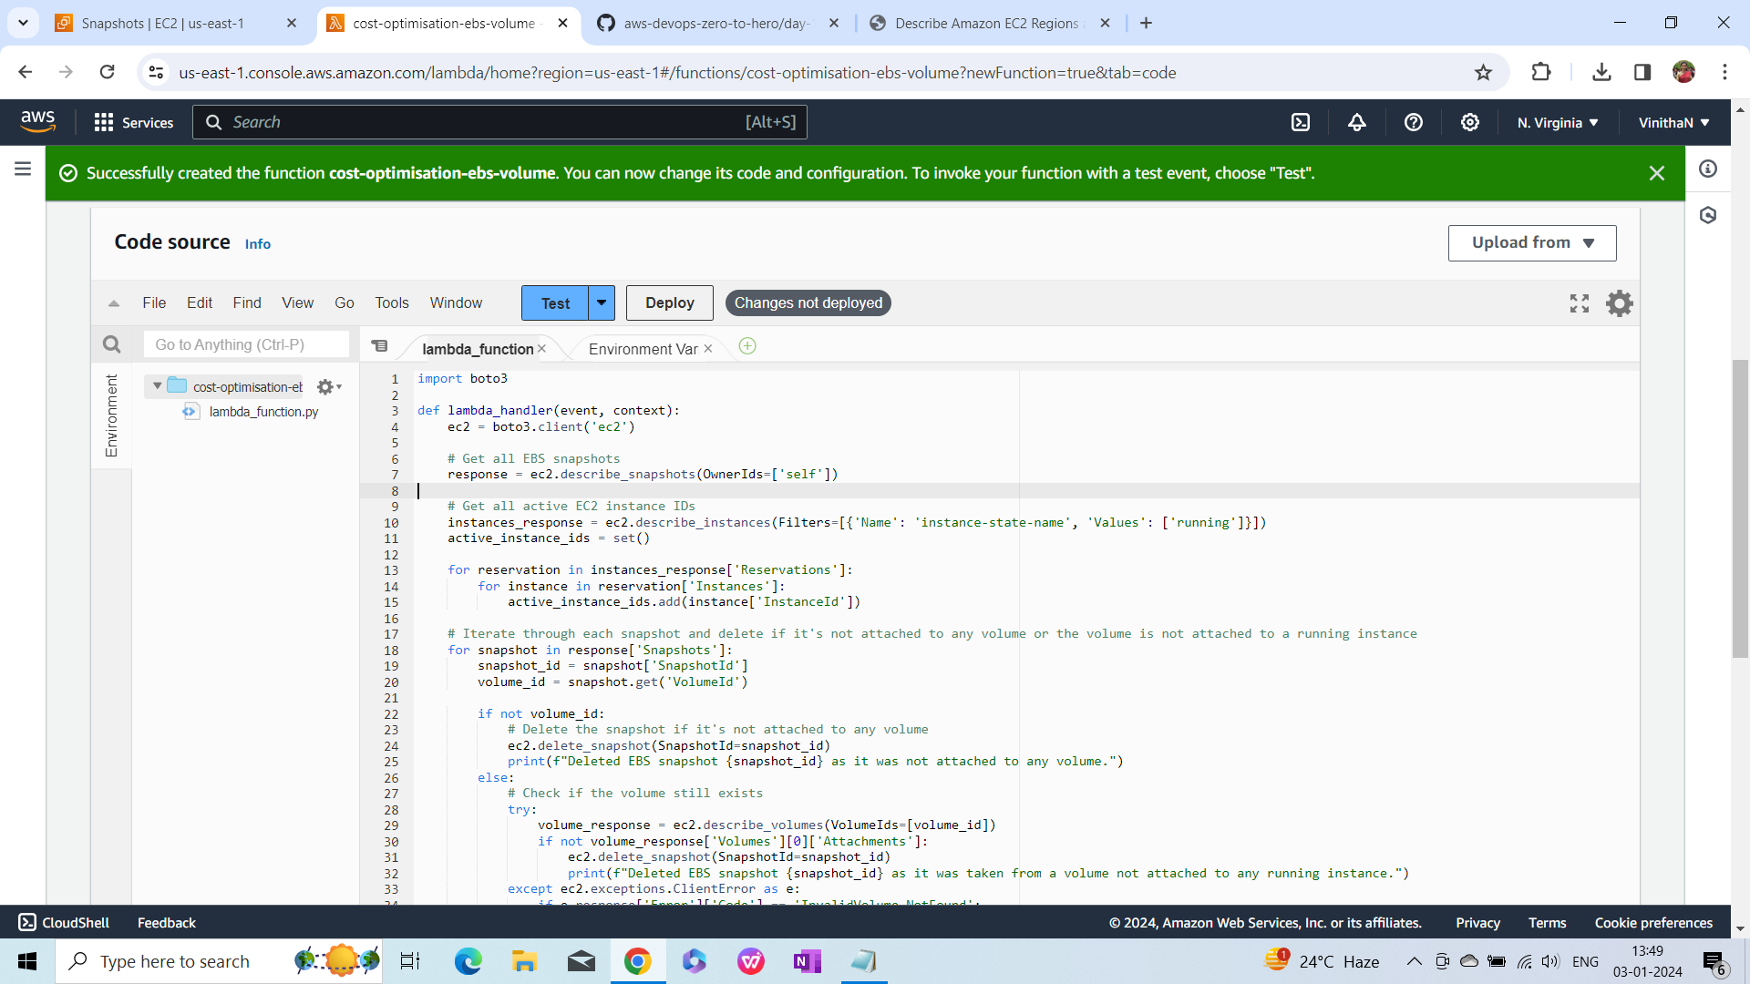

1. Click on Test to create a test event and save

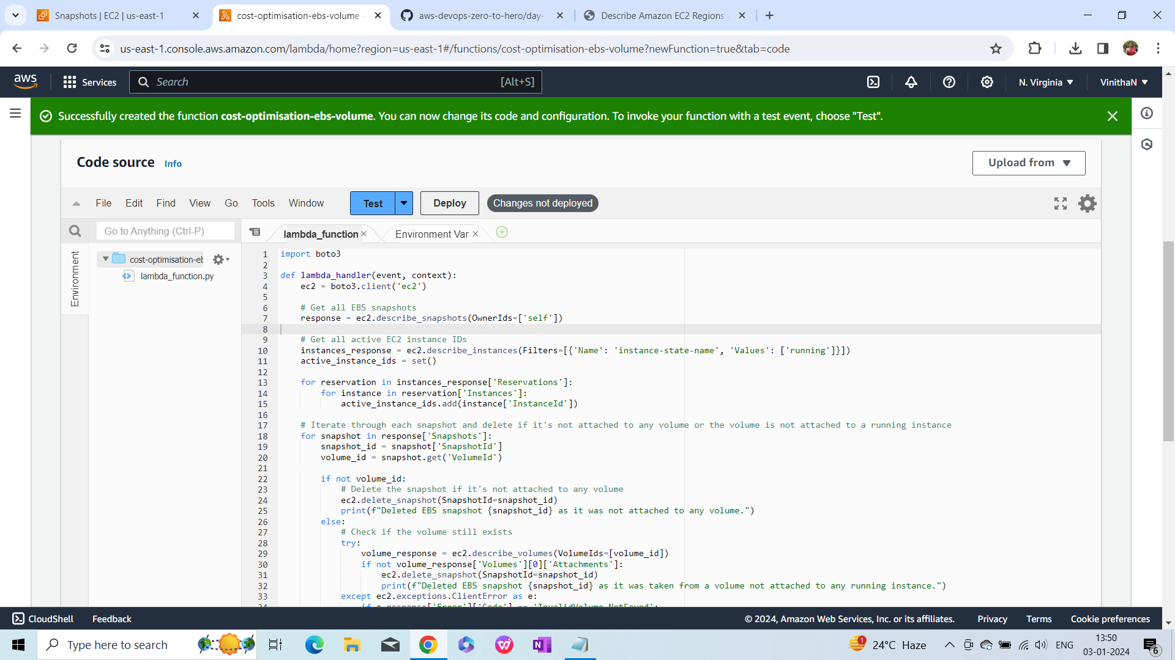

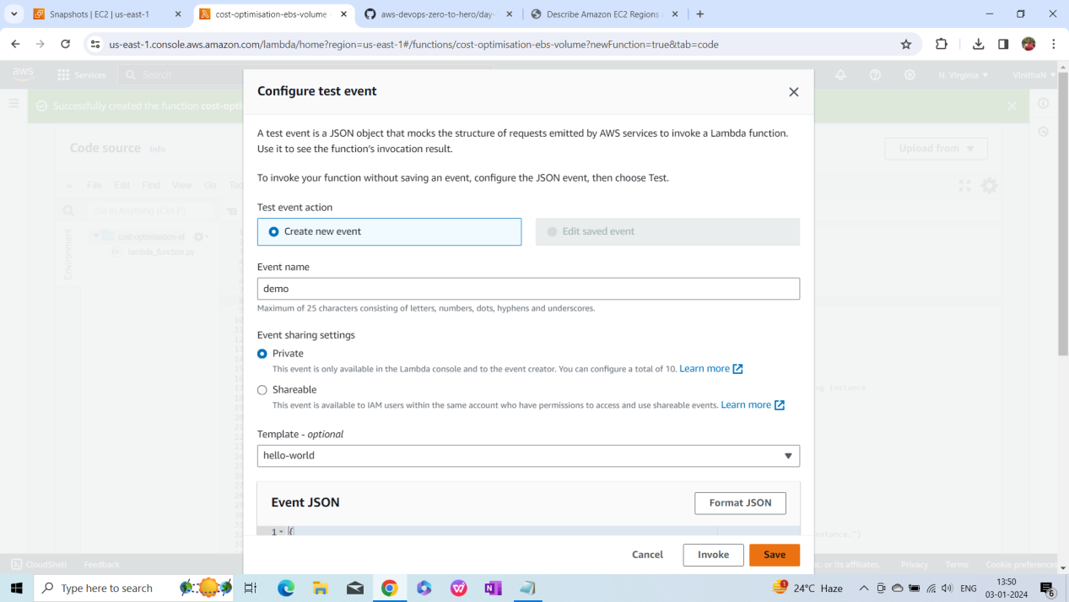

1. Click on Deploy and ctrl+s

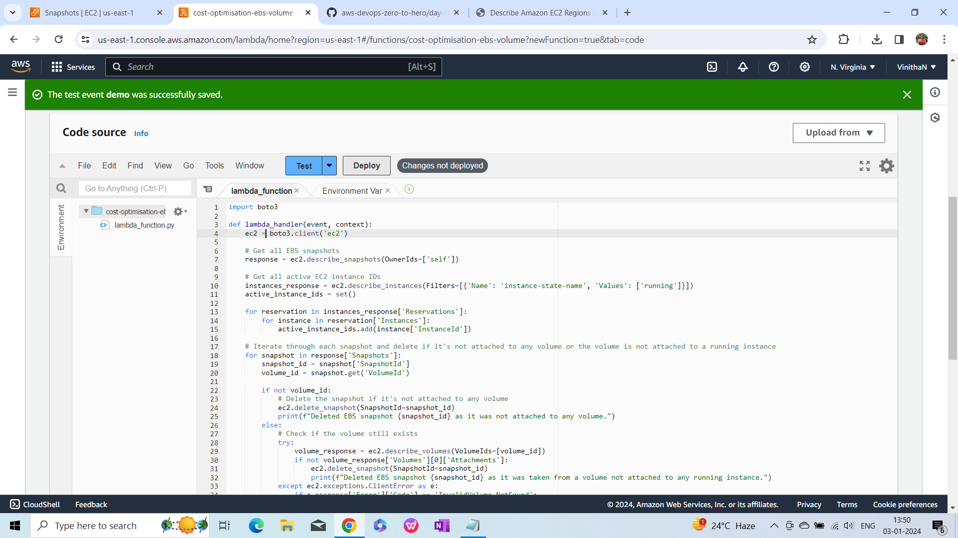

1. Increase the timout to 10s and default timeout is 3s. go to configuration increase the timout for 10s

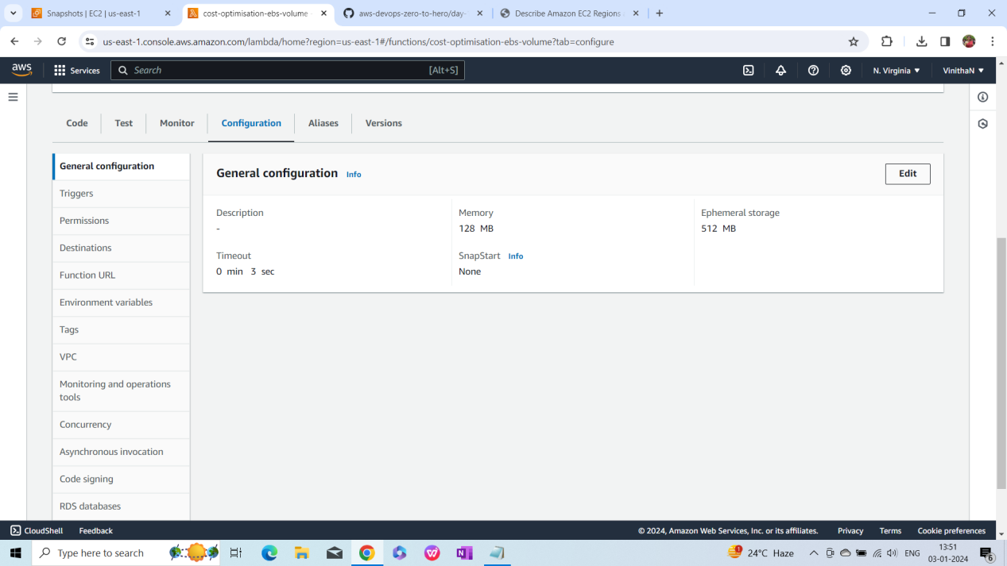

1. Go to configurations again and click on permission AND open role link
2. Create policy to add permission
3. permissions to add to the policy
4. 1 describe snapshots
5. 2 delete snapshot
6. 3 describe instances
7. 4 describe volumes
8. Click on test
9. Terminate the ec2 and Test the code it will delete the sanpshot.
10. 